**An Improved Simplified Heat Stress Management Approach for the Non-Technical User**

**Dr Ross Di Corleto**

# Abstract

The National Weather Service Heat Index Chart has for many years been the go-to in the management of heat stress in a number of countries. It is simple to use, visually easy to interpret and requires limited technical knowledge. Regulators have also utilised it to assist them in their assessments of heat stress exposure scenarios. In 2016 and 2017 OSHA issued five citations to the United States Postal Service (USPS) alleging violations across several locations in the US, referencing the chart. In court, Judge Calhoun of the Occupational Safety and Health Review Commission found that *“no evidence was presented to establish the scientific basis for the risk categories depicted on the NWS heat index chart.”*  Whilst not the only reason, this played a key role in the failure to prosecute.

A mining company in the WA Pilbara region was looking for a similar model but with a more substantive physiological risk-based approach to address this limitation. A project was set up to attempt to deliver a simple tool to meet this criterion. This project involved the utilisation of a very large dataset comprising location climate, workload, and clothing. This data was assessed by applying the ISO 7933 Predicted heat strain model to estimate the time the predicted core temperature reached the WHO level of 38°C.

From this, a series of three coloured charts for low, moderate, and high metabolic load tasks at specific air temperatures and humidities was developed. This was further enhanced by linking the charts to a response plan to provide additional guidance in addressing each condition. To date the model has been used successfully for over 12 months including through a hot summer in the Pilbara, requiring only limited technical support. This paper highlights the process taken to develop the new charts, how they can be used, the benefits and importantly, limitations.

**Introduction**

The National Weather Service Heat Index Chart has for many years been the go-to in the management of heat stress in a number of countries. It is simple to use, visually easy to interpret and requires limited technical knowledge. Regulators have also utilised it to assist them in their assessments of heat stress exposure scenarios.

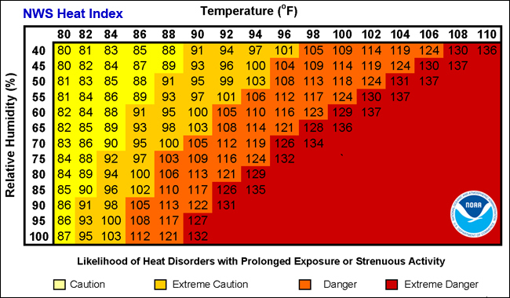

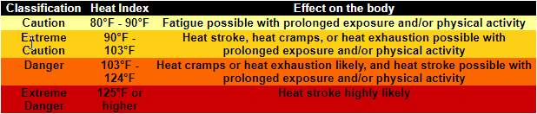

(Source: US National Weather Service[1])

The approach was first published in 1981 in the National Weather Digest in a paper by Quale and Doehring [2] This was developed based on Steadman’s[3] initial work on Apparent Temperature and was primarily written as a guide based on meteorological data. There is limited supporting material on the physiological basis of the risk categorisation in the paper except for a small table inserted into Steadman’s apparent temperature graph on the first page.

This shortcoming was highlighted in the US courts after OSHA issued five citations to the United States Postal Service (USPS) alleging violations across several locations in the US[4], referencing the chart. In court, Judge Calhoun of the Occupational Safety and Health Review Commission found that, *“no evidence was presented to establish the scientific basis for the risk categories depicted on the NWS heat index chart.”[5]* Whilst not the only reason, this played a key role in the failure to prosecute.

In early 2021 after a series of heat related incidents, a mining company in the WA East Pilbara region was looking for a similar model but with a more substantive physiological risk-based approach to address this limitation. The key requirement was that the assessment process was to be simple, easy to use in the field for non-technical personnel and require minimal technical instrumentation. After some initial discussion, a project was set up to attempt to deliver a simple tool to meet this criterion along with some supporting processes to be incorporated into an integrated heat management program.

**Methodology**

The first step, and a key part of the program was to develop reference tables based on a valid physiological base. ISO 7933 Predicted Heat Strain (PHS)[6] was chosen as the basis for this step as it is a widely recognised international standard addressing the physiological criteria. There are a number of inputs required to undertake this assessment which initially proved to be quite daunting on this scale. Key inputs required were:

1. Dry bulb temperature (°C)
2. Globe temperature (°C)
3. Relative Humidity (%)
4. Air velocity (m/s)
5. Clothing Insulation Factor (clo)
6. Metabolic rate (w/m2)
7. Posture
8. Acclimatisation

The environmental parameters that were required were obtained from an onsite weather station, which provided real-time monitoring results for inputs 1, 3 & 4. Globe temperature was not provided by the weather station however it did record solar radiation (W/m2). This was able to be utilised to calculate the globe temperature using the equation developed by Hajizadeh et al (2017)[7].

Clothing insulation factor was based on a standard cotton shirt and trousers ensemble commonly worn by the operators in the Pilbara and referenced to ISO 9920[8]. Metabolic rate was based on a job rates physical demand assessment previously undertaken for the company by a private consultant and referenced back to ISO 8996[9]. An example from the standard is presented in Table 1.

Posture was assumed to be standing, as the majority of tasks undertaken in the work environment were in that position. Whilst it was acknowledged that acclimatisation is an important factor, to minimise complication it was decided to assume individuals would be acclimatised and that a separate process would be included in the overall program to address those deemed to be unacclimatised.

The environmental data utilised was for the months of December 2021 and January 2022 as the meteorological station on site had only been recently set up. Whilst data was continually collected over a 24-hour period, only that between the hours of 0600 hr and 1800hrs and recorded every fifteen minutes, was used in the project. The four specific environmental parameters required, amounted to approximately 24,000 data points which would also require assessment against the varying metabolic loads of the different tasks. It became obvious very early in the project that it would be impractical to try to analyse this volume of data and condense it into one table.

Three key decisions were made at this point:

1. Data would be averaged hourly instead of 15 minutes for three key periods of the work shift, morning, midday and afternoon.
2. Three tables would be developed rather than one, based on set metabolic loads.
   1. High workload (230 W/m2)
   2. Medium workload (175 W/m2)
   3. Low Workload (115 W/m2)
3. Instead of using all the varying air velocities, one based on the average air velocity during the 12-hour period for the two months would be calculated.

Table 1. Examples of metabolic workloads (ISO 8996,2004).

|  |  |
| --- | --- |
| **Metabolic Load** | **Examples** |
| **Light (115 W/m2)** | Casual walking over level terrain (speed up to 2.5 km/h); General hand and arm work (small bench tools, inspection, assembly or sorting of light materials); arm and leg work; Standing drilling. |
| **Medium (175 W/m2)** | Sustained hand and arm work (hammering in nails, filing); arm and leg work (off-road operation of lorries, tractors or construction equipment); arm and trunk work (work with pneumatic hammer); intermittent handling of moderately heavy material, pushing or pulling lightweight carts or wheelbarrows, walking at a speed of 2.5 km/h to 5.5 km/h. |
| **High (230 W/m2)** | Intense arm and trunk work; carrying heavy material; shovelling; sledgehammer work; sawing; hand mowing; digging; walking at a speed of 5.5 km/h to 7 km/h. Pushing or pulling heavily loaded hand carts or wheelbarrows; chipping castings; concrete block laying. |

Utilising the collated data, scenarios were calculated initially via two programs, the author’s privately owned desktop program and one downloaded from the University of Thessaly, FAME computer program.

Unfortunately, the latter tended to freeze and lock up the computer, so an alternative was sourced from Lund University Faculty of Engineering website[10].

As each scenario was assessed it was allocated a colour code. The colour coding in the PHS Metabolic workload tables was based upon fit healthy acclimatised workers and represents the predicted time range in which they may exceed the World Health Organisation[11] recommended limit of 38°C core temperature.

The colours represent the following:

* Red zones are in less than 30 minutes.
* Amber zone in the range of approximately 31 to 120 minutes,
* Yellow from 120 to 240 minutes, and
* Green zones indicate greater than 240 minutes.

Each of the tables was gradually built up as per Figure 1.

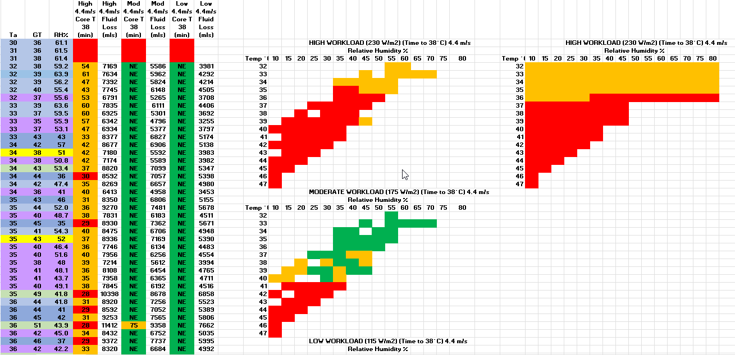

Figure 1. Progressive Development of Charts

The final resultant tables are illustrated in Figures 2, 3 & 4. It should be noted that some of the extreme conditions towards the bottom right-hand corner the table were not all calculated but were extrapolated from the earlier data.

Figure 2. Completed Low Metabolic Work Rate Chart.

Figure 3. Completed Medium Metabolic Work Rate Chart

Figure 4. Completed High Metabolic Work Rate Chart

**Discussion**

The three charts required the most extensive resource commitment to develop and were key to the first part of the management program. However, it is important to note that the charts should be utilised as part of the overall heat stress management programme. They are not a stand-alone tool. Also included in the programme were:

* A training programme for employees developed to accompany the approach,
* Simple toolbox information sheet for the supervisor
* Colour coded basic thermal risk assessment to identify potential controls.
* Heat stress response guide
* Critical control operator heat stress card.

This project was run alongside a hydration awareness program during the trial of a saliva testing protocol.

To use the programme:

1. Identify the air temperature and humidity, either from the site weather station or by measurement with an instrument directly at the work location.
2. Assess the type of work to be undertaken in the task, for example simple inspection or walk around (Low), general maintenance with hand tools (Medium) or heavy manual labour such as digging holes or trenches by hand (High). More detailed examples are presented in table 1 above.
3. Refer to the relevant PHS chart to identify the colour code.
4. Use the colour code to identify the appropriate actions required from the Heat Stress Response Guide corresponding colour column.

This is presented visually in the flowchart in figure 5.

Figure 5 PHS Flowchart

As a separate exercise, aligning the colour coding with the thermal work limit (TWL) result was also utilised as a trigger for the Heat Stress Response Guide for comparison. Whilst still early days, the alignment was quite good.

The integrated programme relies heavily on colour coding as an indicator of risk and control and by doing so provides the simplicity that is important for such a process to work in the field for the operator. It has also reduced the requirement of technical instrumentation at this level. Where scenarios predicted significant risk or uncertainty they were directed by the heat stress guide to seek technical expertise for advice.

Feedback from the sites using the model was important to determine whether the key criteria were addressed. This feedback included:

* *Usefulness of Model Charts:* The model charts have indeed proven to be valuable. The structured approach they offer in assessing data and trends has been beneficial by those who have utilized them. The clear visualisation and systematic representation have enabled quicker decision-making and enhanced insights into the data, in conjunction with TWL readings.
* *User-Friendliness:* Users, regardless of their technical background, have found the model charts fairly accessible. The effort you've put into making them user-friendly has paid off, as the majority of feedback indicates a positive experience. Those without a technical background have expressed appreciation for the simplicity of the charts and their ease of interpretation.
* *Measurable Improvement in Heat Illnesses:* There is evidence of a significant improvement in the reporting of heat-related illnesses signs and symptoms.
* By utilising the charts, the early identification of potential risks has improved, leading to proactive measures being taken to prevent heat-related issues. This has undoubtedly contributed to a decrease in heat illnesses. Need to tighten up the language around “level 3 response”, specifically, there is a point where work is not practicable in that heat and presents cardiac risk.

The programme has been designed to ensure the control focus is on higher level controls and wherever possible move away from purely administrative or behavioural controls. They have their place but in situations where production targets loom or peer pressure exists, these controls tend not to perform well.

Of key importance in any programme is the commitment of the health and safety leaders and management of the company. Some of the new approaches and interventions were quite a paradigm shift in heat stress management and not always easy to accept but were at least given the opportunity.

**Conclusion**

This programme was developed for a mining and exploration company that operates in one of Australia’s harshest thermal environments in the northwestern region of the country. Key criteria were that a component of the approach needed to be similar to the NWS Heat Index Chart, i.e., simple and easily adopted by the frontline but that the overall programme reduced the heat stress risk to the employees and contractors.

During the trial the temperatures often exceeded 40 degrees centigrade for extended periods. The programme introduced several new tools for the management of heat stress in these environments. Some are used regularly others only rarely but are there if needed.

Ultimately the measure of the success or otherwise of a programme is gauged by the level of the reduction of heat incidents/illnesses. In the summer preceding the development of the programme there were approximately forty heat stress related incidents reported at the company’s sites. In the summer after the implementation of the new programme there were only **four**. The company’s goal is to achieve zero and they are well on the way there.

**Limitations**

In any project requiring the collection and assessment of data to establish a new concept there are limitations. Some that are associated with this exercise include:

1. Heat stress index calculations are based on fit, healthy participants, 90kg, 1.8m.
2. Globe temperatures were calculated from meteorological data.
3. An averaged air velocity for the period and specific to the region was used rather than multiple variables.
4. Data from two months of the year: a larger database would have been preferred.
5. Posture was limited to standing.
6. ISO 7933 has not been fully validated for some of the extreme conditions experienced.

Further research is required to address some of the above limitations and then undertake a physiological validation of the charts in the field.

**References**

1. http:// https://www.weather.gov/ama/heatindex
2. Quale, R., Doehring, F., (1981). Comparisons of Heat Stress Indexes (with applications to indoor room temperatures in winter). National Weather Digest
3. Steadman, R.G., (1979). The assessment of sultriness. Part I: A temperature humidity index based on human physiology and clothing science, and Part II: Effects of wind, extra radiation and barometric pressure on apparent temperature. J. Appl. Met., Vol. 18, No.7 pp. 861-884.
4. <https://ogletree.com/insights/judge-finds-no-scientific-basis-for-nws-heat-index-chart-used-by-osha-in-heat-stress-cases/> Accessed 15/06/2023
5. Occupational Safety and Health Review Commission. (2020). Notice of Decision. Secretary of Labor v. United States Postal Service. OSHRC Docket No.: 16-1813.
6. ISO 7933 (2004). *Ergonomics of the thermal environment - Analytical determination and interpretation of heat stress using calculation of the predicted heat strain*. International Organisation for Standardisation, Geneva
7. Hajizadeh, R., Farhang Dehghan, S., Golbabaei, F., Jafari, S.M., Karajizadeh, M., 2017. *Offering a model for estimating black globe temperature according to meteorological measurements.* Meteorological Applications 24, 303–307.. doi:10.1002/met.1631
8. ISO 9920 (1995). *Ergonomics of the thermal environment - Estimation of the thermal insulation and evaporative resistance of a clothing ensemble*. International Organisation for Standardisation, Geneva.
9. ISO 8996 (2004). *Ergonomics of the thermal environment -Determination of metabolic rate*
10. Lund University webpage: <https://www.eat.lth.se/fileadmin/eat/Termisk_miljoe/PHS/PHS.html>
11. World Health Organisation. Technical report series No 412., *Health factors involved in working under conditions of heat stress.* Report of a WHO Scientific Committee. Geneva 1969